AI CONTEXTUAL CHATBOT

ABSTRACT
The main aim and objective of this project is to build a AI Chatbot for Cyber Security Industry. We can see chatbots are being encouraged and adopted by many of the industries and universities like “Make my Trip”, “Lovely Professional University”, etc. In project we tried to build a chatbot focused for Cyber Security industry and trained it in such a way that other than the company Information it can also entertain some of the basic security quires.
INTRODUCTION
Chatbots are basically AI intelligence bots which can interact with the user or customers depends upon the usage. It is an application of Artificial Intelligence and Machine Learning. Now-a-days technology is increasing rapidly. In this technological world every industry is trying to automate things to provide better services. One of the great application of automation would be chatbot.
There are basically two types of Chatbots :
Command based: Chatbots that function on predefined rules and can answer to only limited queries or questions. Users need to select an option to determine their next step.
Intelligent/AI Chatbots: Chatbots that leverage Machine Learning and Natural Language Understanding to understand the user’s language and are intelligent enough to learn from conversations with their users. You can converse via text, speech or even interact with a chatbot using graphical interfaces.

Here in this project we created an AI Chatbot which is focused for Cyber Security Industry and trying to solve of the use cases of industry by training it in such a way that it can answer some of the basics queries of cyber security as well other than just the customer services.
LITERATURE REVIEW
The AI Chatbot is being implemented by many of the industries. The basic concept behind it is NLP and Neural Network. Chatbot can be build by many different ways and many different libraries are available in python like “chatterbot”. One of the blog of edureka described the use of chatterbot [1]. It is a module with pre-defined methods for building Chatbot. The concept that we used is building a neural network by tensorflow and tflearn [2]. Also for more clarification we took help from you tube channel “The AI University” [3].
METHODOLOGY
The methodology that we used for this application is very simple. We used the concept of Natural Language Processing and building our own Neural network by using tflearn. We have used a json file “intents.json” for training our model. The intents.json is the file which consists of some sample chats and each chat block under a “tag”.
This intents file is being created by our team and we have not used any file from internet. We have provided some basic chats regarding the Cyber Industry and some basics terminologies and some basic queries related to Cyber Security.
We used this file for training the model and the model is being trained by using fit() method of tflearn and saved the model as “model.tflearn”. All the trained data is being stored in a file named “training_data” and further this file is used for giving response.
RESULTS AND DISCUSSION
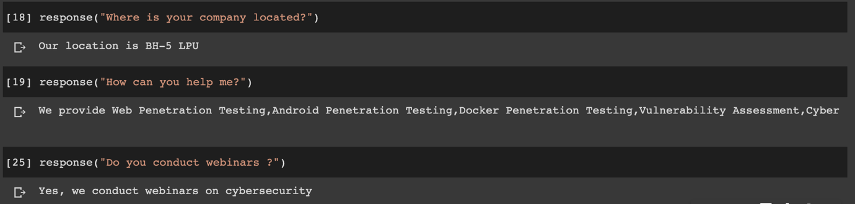
Our AI Chatbot is intelligent as it can answer the question even if it not the exact same as we provided in training data. It also reply in the same context as the user is taking with.

CONCLUSION
We conclude that chatbots build with NLP and Neural Network are more efficient than just by using pre-defined libraries of python for building chatbot. AI Chatbots can save time as well as labour work and are more efficient by providing 24*7 services.

REFERENCES

[1] https://www.edureka.co/blog/how-to-make-a-chatbot-in-python/
[2] https://chatbotsmagazine.com/contextual-chat-bots-with-tensorflow-4391749d0077
[3] https://www.youtube.com/channel/UCv6Uw36LRbYnX4HDxKPguKg

